MIDTERM EXAMINATION
Fall 2008
MTH101- Calculus And Analytical Geometry (Session - 2)

Question No: 1 ( Marks: 1 ) - Please choose one
Consider two function
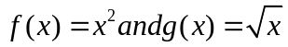 then 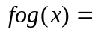..................

►
► 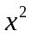
► 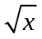
► None of these

Question No: 2 ( Marks: 1 ) - Please choose one
Natural domain of
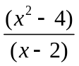 is

► 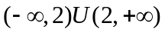
► 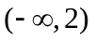
► 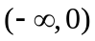
► None of these

Question No: 3 ( Marks: 1 ) - Please choose one
The solution of the inequality
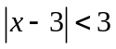 is

► (-1,7)
► (1,7)
► (1,-7)
► None of these

Question No: 4 ( Marks: 1 ) - Please choose one
If a quantity y depends on another quantity x in such a way that each value of x determines exactly one value of y , we say that y is ………………. of x

► relation
► none of these
► function
► not function

Question No: 5 ( Marks: 1 ) - Please choose one
The set of all points in the coordinate plane which are at a fixed distance away from a given fixed point represents
► Parabola
► Straight line
► Circle
► None of these

Question No: 6 ( Marks: 1 ) - Please choose one
Let L₁ and L₂ be non vertical lines with slopes m₁ and m₂ ,respectively Both the lines are perpendicular if and only if

► 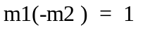
► 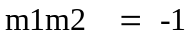
► 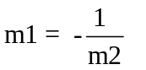
► All of these

Question No: 7 ( Marks: 1 ) - Please choose one
The equation
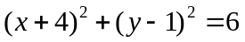 represents a circle having center at ……….. and radius ................

► 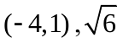
► 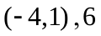
► 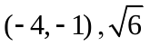
► None of these

Question No: 8 ( Marks: 1 ) - Please choose one
The base of the natural logarithm is

► 2.71
► 10

► 5
► None of these

Question No: 9 ( Marks: 1 ) - Please choose one
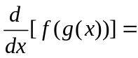

► 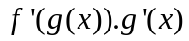
► 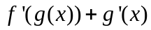
► 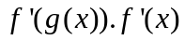
► None of these

Question No: 10 ( Marks: 1 ) - Please choose one
If y=f(g(h(x))) and u=g(h(x)) and v=h(x) then


► 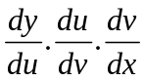
► 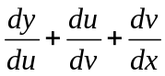
► 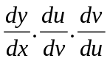
► None of these

Question No: 11 ( Marks: 1 ) - Please choose one
The tan(x) is discontinuous at the points where

► Cos(x) =0
► Sin(x) =0
► Tan(x) =0
► None of these

Question No: 12 ( Marks: 1 ) - Please choose one
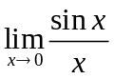 Equals to

► 1
► 2
► 3
► 0

Question No: 13 ( Marks: 1 ) - Please choose one
Both Sin(x) and Cos(x) have the same limit and function value at x=0 so both are ...................... at x=0

► Continuous
► Discontinuous
► Linear
► None of these

Question No: 14 ( Marks: 1 ) - Please choose one
For a function f(x) to be continuous on interval (a,b) the function must be continuous

► At all point in (a,b)
► Only at a and b
► At mid point of a and b
► None of these

Question No: 15 ( Marks: 1 ) - Please choose one
is called

► An integer
► A rational number
► An irrational number
► A natural number

Question No: 16 ( Marks: 1 ) - Please choose one
The graph of the equation
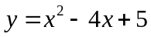 will represent

► Parabola
► Ellipse
► Straight line
► Two straight lines

Question No: 17 ( Marks: 2 )
Let
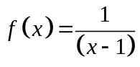. Find the average rate of change of f over the interval [3, 5].

Question No: 18 ( Marks: 2 )
Solve this quadratic equation: ax² +bx = 0

Question No: 19 ( Marks: 3 )
Find
 if 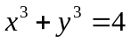

Question No: 20 ( Marks: 5 )
Find an equation of the line through A (-6, 5) having slope 7.

Question No: 21 ( Marks: 10 )
Show that the points A(0,2) ; B(
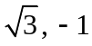) ; C(0,-2) are vertices of right triangle.

